A Review of Hybrid Replica of Character Recognition Practices

Indu Chhabra
Department of Computer Science & Applications, Panjab University, Chandigarh
Email: chhabra_i@rediffmail.com
chhabra_i@yahoo.com

Chandan Singh
Department of Computer Science & Engg., Punjabi University, Patiala.
Email: chandan@pbi.ac.in

ABSTRACT

Linguistic resources such as shape extraction are critical for the development of language technologies such as script and speech recognition. The motivation behind this paper is to locate and implement the knowledge informants capable of inferring the shape of character object and recognizing it into appropriate character class through Simplified Fuzzy Adaptive Resonance Theory Map. Various technical and implementation issues regarding the selected set of features, tolerance to scale, distortion and style variation have been explored. A blend of font and size independent statistical methodologies such as Directional Distribution, Zernike Moments and Geometrical Moments have been presented to provide the one integrated feature vector to be fed as input to Fuzzy network. This review presents a modified approach in terms of scale and font invariance properties as the classifier is trained with well designed database of nine various fonts of each character with three varying sizes. The experimental results show that the proposed approach is fast and results in a higher performance regarding scale, rotation and font invariance properties.

Keywords: Knowledge informants, Fuzzy systems, Statistical properties, Moment Invariants.

1. Introduction
The objective of Character Recognition is to understand the concept of character’s shape and the mechanism that identifies any instantiation of this concept. Since the late 1960s, research on recognition of a character has made an impressive progress and many systems for the recognition of English, Chinese and Arabic languages [11] but there are few systems for recognition of Indian languages such as Hindi, Tamil, Bangla and specially Gurumukhi [1,2]. Now days though many character readers are commercially available but due to their limited capabilities, they cannot recognize the characters with full accuracy as human can. They can work only under certain conditions:
- These can accommodate only little variation in shape with little noise but find difficult to recognize characters of multiple fonts and multiple sizes with heavy noise.
- Touching and broken characters are non-segmented strings of characters so cannot match with stored pattern and hence difficult to identify.
- In case of loosely constrained characters it is difficult to preserve the topological properties of the shape hence the recognition rate decreases.
Thus today Character recognition is still a very critical area of research. The character recognition process involves mainly three steps: Image preprocessing, Feature Extraction and Classification. Preprocessing is primarily used to remove noise, skew ness and distortion in a character and to obtain its skeleton. Feature extractor extracts meaningful shape properties from a character in form of set of numeric values for lateral processing. The classifier is used to make a final decision about the character class according to extracted features and acquired knowledge. In achieving the high recognition performance, the selection of feature description method is probably the most important factor. Features can be extracted from binary image, its skeleton or its contours. Global statistical features describing the attributes of the whole character and local structural features denoting its constituent parts and their relationships are the two mostly trends used for feature description.
This discussion offers a solution for the invariant recognition of a character irrespective of its size, orientation and position. Due to such variations a single character class may have more than one feature description with little variations, hence the aim is to choose those feature extraction practices that reduce the with-in class differences while maintaining the between-class variations. We have considered Gurumukhi script for the case study, which is the most widely used language in northern India as well as the 11th most spoken language in the world. Having its wide applicability in the international market like USA, UK and other countries, the “Optical Character Recognizer” of this language is in great demand. Recently to promote it in the international market, the UK Government has sanctioned an international project of converting “Shahmukhi to Gurumukhi Script” to the “Center for Natural Language Processing”, Punjab, India.

2. Character Recognition Practices
The proposed review derives the various shape features of a character with statistical techniques against the conventional structural approach, where recognition is performed according to structural similarities. Statistical approach relies on the statistical decision theory, where a character is viewed as an ordered array of n-numerical values. These are derived from the statistical distribution of image pixels so make up size, rotation and translation invariant characteristics. These are also tolerant to distortion and take care of style variations to some extent. In the present work, some well-recognized statistical methods like Directional Distance Distribution, Geometric Moments, Zernike Moments and Pseudo Zernike Moments are investigated for their geometric invariance as well as for their recognition accuracy with Neuro–Fuzzy self-adaptable classifier. The results are shown in section 5.

2.1. Directional Distance Distribution
This new feature[8] has proved a very promising in building a reliable character recognition system because It has a better discriminating power as it is build on the new concept of representing the input pattern array as being circular, so taking care of the patterns which are in different classes but having common shape in part of the pattern. This feature is based on the distance information computed for both from black pixel to white pixel and from white pixel to black pixel in eight directions, so it contains the both black and white distribution and the directional distance distribution.
Computing and encoding in DDD feature
In this feature each of pixel is allocated two sets - W and B, of 8 bytes each. For a white pixel: set W is used to encode the distance to nearest black pixel in 8 directions with the direction codes 0(E), 1(NE), 2(N), 3(NW), 4(W), 5(SW), 6(S), 7(SE) and set B is simply filled with value zero. Likewise, for a black pixel: set B is used to encode the distance to nearest white pixel in 8 directions and set W is simply filled with value zero.

2.2. Geometric Moments
Moment invariants are the quantitative value of the pixel distribution around the center of gravity of the character image. Introduced by Hu and revised by Reiss [3], the absolute centralized moments are derived from the algebraic invariants that are applied to the moment generating function under a rotation transformation. Thus the result is set of absolute invariant moments that are used for scale, position, rotation and skew invariant pattern identification. To capture the global character information, seven φ_{1,}φ_{2,...}φ₇[4] invariant moments have been computed from normalized centralized moments (μ₀₂, μ_{03,} μ_{11,} μ_{12,} μ_{20,} μ_{21,} μ₃₀ ) up to order three.

Figure 1. a) Original b) Rotated at 5⁰
c) Half Size d) Rotated at 45⁰
Invariants for general linear transformation are computed via relative invariants Ij, which is a function of the moments in the original ( x,y ) space.
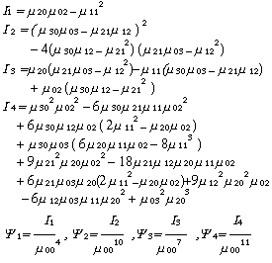
Hu 11  Moments | Original  0⁰ 32×32 | Rotated  5⁰ | Rotated  45⁰ | Half Size  16×16
Phi 1  Phi 2  Phi 3  Phi 4  Phi 5  Phi 6  Phi 7  Psi 1  Psi 2  Psi 3  Psi 4 | 0.5498  2.1953  3.7642  3.4170  7.2234  4.5708  7.1447  1.4817  6.2337  4.1114  6.0550 | 0.5263  2.1681  3.5670  3.3055  6.9443  5.7912  6.8888  1.4420  6.0190  4.2429  5.2267 | 0.5323  2.1090  3.3291  3.1327  7.0731  4.8817  6.1419  1.3592  5.9295  4.1808  5.0571 | 0.5780  2.1109  3.4208  3.3759  8.4547  4.7013  6.7746  1.5434  6.2375  4.2173  5.5971

Table 1. Geometric Moment Invariants.

Figure 2. Scale and Rotation Invariancy for Geometric moments

The images, a character from Gurumukhi script, shown in Figure 1(a) is reduced to its half size (c) and rotated by 5⁰ and 45⁰ (b and d). Then the above-defined eleven moments are computed on each of these images [Table 1]. As shown in Figure 2, the results for images 1 (b–d) are in reasonable agreement with invariants computed for the original image.

2.3. Zernike moments
The Zernike moments are the projections of input image onto the space spanned by the orthogonal V-functions (1). These moment functions are defined by a polar coordinate representation of the image space to generate pattern features that are invariant with respect to change of size, rotation and translation to little extent. As compared to conventional geometric moments, Zernike moments have been proven to be more robust in the presence of noise and are outperforming them in terms of information redundancy and reconstruction capability.
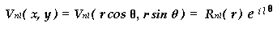 … (1)
Where are the real-valued radial polynomials defined as:
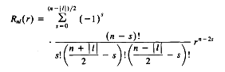
Zernike moments of order n are constructed using a set of complex polynomials, which form a complete orthogonal basis set defined on the unit disc

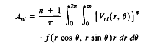
where , is the function being described, * being the complex conjugate and l a positive or negative integer depicting the angular dependence or rotation subject to conditions and is even.
As reported in the literature [5,6] zernike moments up to order 13 have been used to obtain the best results. To check the reliability of the zernike moments in character recognition, the character image is reconstructed with the following function

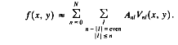
The absolute value of zernike moments are rotation invariant as the image is mapped to a unit disk. As these moments are not translation and scale invariant, so to make it invariant to translation the origin of the image is shifted to center of gravity before calculating the moments. Normalizing the calculated moments with scaling factor, by which the image is scaled, gets scale invariants. The Figures 3 and 4 shows the rotation and scale invariants for the images of figure 1(a-d) and prove the out performance of zernike moments over the geometric moments as the magnitude of scaled and rotated moments are approximately equal to original moments. Due to their orthogonallity and reconstruction ability, these are providing more promising results.
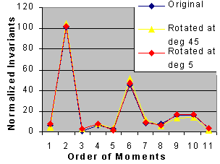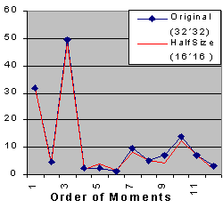
Figure 3. Rotation Invariants Figure 4. Scale Invariants

2.4. Pseudo Zernike Moments
Pseudo Zernike Moments are derived from the requirement of orthogonal and invariance properties. Pseudo polynomials, being invariant in form with respect to rotations of axis about the origin, are polynomials in x, y and r differs from that of Zernike in the real-valued radial polynomials defined as

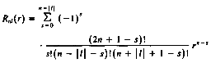

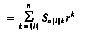

where and l takes positive and negative integer values subject to only. This set of pseudo-zernike polynomials contains (n +1)² linearly independent polynomials of degree <= n, whereas the set of zernike polynomials contains only ½ (n+1)(n+2) linearly independent polynomials of degree <=n due to the additional condition of is even. So, in case of noise these moments outperform the zernike moments due to their better reconstruction ability with less order as compared to zernike.

3. Categorization with Simplified Fuzzy Adaptive Resonance Theory Map (SFAM):

The last main stage is categorization of the unknown character to one of the given classes for its exact identification. The classification phase has been implemented with SFAM network. Several processing units, called fuzzy neurons, have been fully connected to make an artificial fuzzy system (Figure 5, ‘Network topology’).
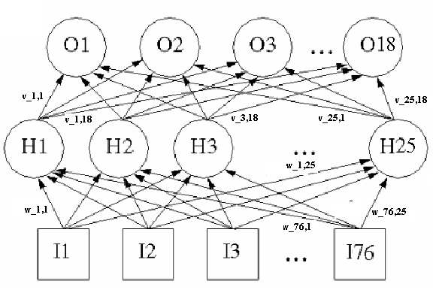
Figure 5. Network Topology

The proposed fuzzy system is consisted of seventy-six inputs, twenty-five hidden nodes, and eighteen classes (#O1 to #O18). The neurons are connected by a large no. of weighted links over which signals can pass. Initially the connections are assigned random weights, which are modified as the network is being trained for the given classes. Training begins with just one hidden node whose weights are set equal to the first record and prediction is set equal to the class of the first record. Whenever a new class is encountered a new node is created. The node whose weights best match the current input supplies the prediction, provided the degree of match exceeds the vigilance threshold value. If this prediction is correct, the weights of this winning node are adjusted toward this input. If the prediction is wrong or vigilance threshold is not achieved, a new node is created with weights and prediction equals to this record. After learning it has been tested for unknown characters for its best mapping into one of the given classes. To improve the recognition rate, two different kinds of fuzzy subnets have been used for two different stages based on connections of Gurumukhi characters with the top line of the character itself.

- Experimental Study
  - Data Set: The dataset of 35-letter gurumukhi script in 9 various font and silhouettes in three varying sizes 30*40, 25*35 and 20*30 has been designed to make up 27 images per class so having total 945 images to be examined.
  - Preserving Shape Features :In literature most of the algorithm derive the features of the character from standard shape but in present research the image is preprocessed before the application of feature extraction procedure and has been analyzed whether these procedures provide better results with preprocessing or not, if it is the case then the preprocessed image is derived from the standard one before its further analysis. For example Directional Distance Distribution provides more accurate results when applied to the thinned image.
  - Error Rate: To estimates the error rate associated with given feature methods, the available dataset is divided into two sets one for training and one of testing. “ Leave -one –out ” method has been used where out of N samples from C classes per database (N-1) of them are used to train the classifier and remaining one to test it. To test the sensitivity of the system to slight variations, the classifier is trained on five fonts in all three sizes and tested with the remaining in each cycle.
  - Analysis of Noisy characters: Moment invariants using various schemes, as defined in the previous section, have been shown to provide perfect invari ance properties under noise-free condition. However, in the presence of noise, the computed invariant moments are expected not to be strictly invariant. Thus, it is important to investigate which invariance scheme is less vulnerable to image noise. In order to evaluate the effect of noise on various types of moments of different orders and to compare how various types of moments are affected by noise, we define the normalized signal-to-noise ratios of order (p, q) as
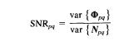where and are the variances of and respectively. The SNR’s for different moment sets have been evaluated and listed in Table 2.
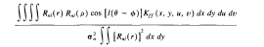

Table 2. Signal-to-noise ratios for moments
The following observations follow from Table 2.
1. If the random field f (x, y) has equal correlation in the horizontal and vertical directions then and have the same SNR’s.
2. The radial polynomials depend only on the absolute values of repetitions l. Thus Zer-
nike moments and have the same SNR’s. This is also true for pseudo-zernike moments.
3. for both Zernike and pseudo-Zernike moments have the same SNR’s since .

5. Classification Results
The performance of all described features is compared with Fuzzy Adaptive classifier on gurumukhi dataset of total 945 samples. The results are presented in the Table 3.
Table 3. Recognition Accuracy Figure 6. Performance Evaluation
Feature  Type | Leave One Out | Train on  One Silhouette
Directional Distribution  Zernike moments  Pseudo moments  Geometric moments  Integrated vector | 96  96.69  96  94  95 | 92.26  93.78  94  88  92

The result of Figure 6 shows the out performance of zernike and pseudo zernike moments over Hu geometric moments due to their orthogonality and reconstruction ability over the image region.

6. Conclusion
The methods for invariant recognition of a character object irrespective of its scale, position and orientation, are presented. Unlike traditional structural methods where the different sizes of same character are standardized to achieve scale invariance, the character attributes are extracted from the original shape to avoid the affects of shape standardization and afterwards these attributes are made scale invariants. Different well-applied statistical feature extraction techniques are investigated for their optimal performance. For the relative analysis, these are experimented with neuro-fuzzy classifier.
References

- Negi, A., Chereddi, C.K. (2003), ‘Localization, Extraction and Recognition of Text in Telgu Document Images’, In Proceedings IEEE conference, pp 18-25.
- Chandrasekaran, R., Chandrasekaran M. and Siromony G (1984 ) ‘Recognition of Tamil, Malayalam and Devnagri characters’, Journal of. Inst. Electron. Telecom. Engg., pp 150-154.
- Reiss, T. H (1993), ”Recognizing Planar Objects Using Invariant Image Features”, Lecture Notes in computer Science, Springer-Verger, Berlin, pp. 676-680.
- Govindan and Shiva Prasad (1999), ”Character Recognition—A Review”, Pattern Recognition, 23, pp. 671-683.
- Heutte L., Paquet T., Moreau, J. V., Lecourtier Y. and Olivier, C. (1998), “A structural/statistical feature based vector for handwritten character recognition”, Pattern Recognition letters, 19, 629-641.
- Liao S. X. and Pawlak M. (1999), “On the Accuracy of Zernike Moments for Image Analysis”, IEEE Trans. On PAMI, 20(12), pp. 1358-1364.
- Mori, S., Nishida, H., and Yamada, H. (2000), “On-line and off-line Handwriting Recognition: A Comprehensive Survey”, Pattern Analysis and Machine Intelligence, 22(1), 63-84.
- Jain A.K., Duin P.W. and Mao J. (2000),“ Statistical Pattern Recognition: A Review”, IEEE Trans. On PAMI, 22(1), pp. 4-37.
- Mukherjee P.K. (2004), ”A Data Structure for Interactive Multimedia Database Systems”, IETE Technical Review, 21, pp.3-15.
- Kamila N. K., Mahapatra S. and Nanda S. (2005), “Invariance Image Analysis Using Modified Zernike Moments”, Pattern Recognition Letters, 26, pp. 747-753.
- Badr Ali-Badr and Sabri A. Mahmoud (1995), “Survey and bibliography of Arabic Optical text recognition”, Signal processing, 41, pp. 49-77.
- Trier, O., Jain, A. K. and Taxt, T. (1996), “Feature Extraction Methods for character recognition – A survey”, Pattern Recognition, 29(4), pp. 641-662.

